
Health & fitness tracker
Software Requirements Specifications Documentation

December 1, 2024
Nile University
CSCI313 – Software Engineering

By:
Aly Sakr 221002050
 0
1. Abstract 5
2. Introduction 5
2.1 Purpose 5
2.2 Scope 5
2.3 Technologies Used 6
2.4 Intended Audience 6
2.5 Overview 6
3. Overall Description 6
3.1 Product Perspective 6
3.2 User Characteristics 7
3.3 Constraints 7
3.4 Assumptions & Dependencies 7
4. Functional Requirements 7
4.1 User Class 1 – Regular Users 8
4.1.1. User Authentication: 8
4.1.2. Profile Management: 8
4.1.3. Health Tracking: 8
4.1.4. Fitness Goals: 9
4.1.5. Workout Log: 9
4.1.6. Nutrition Tracking: 9
4.1.7. Integration with Wearable Devices (Optional): 9
4.1.8. Notifications and Reminders: 10
4.1.9. Analytics and Reports: 10
5. Non-Functional Requirements 10
5.1. Performance: 10
5.2. Availability: 11
5.3. Security: 11
5.4. Usability: 11
5.5. Scalability: 11
5.6. Maintainability: 12
5.7. Backup and Recoverability: 12
5.8. Compliance: 12
5.9. Localization: 12
6. System Architecture and Design 13
6.1 Activity Diagram 13
6.1.1 User Registration Process 13
6.1.2 Meal Logging Process 14
6.1.3 Activity Tracking Process 16
6.1.4 Goal Setting and Progress Tracking 18
6.2 UseCase Diagram 19
6.2.1. Actors: 19
6.2.2. Cases: 20
6.2.3. Base Use Case: Login 22
6.2.4. Use Case: Edit Meal 23
6.2.5. Use Case: View Health Metrics 24
6.3 Sequence Diagram 25
6.3.1 User Registration 25
6.3.2 Meal Logging 26
6.3.3 Activity Tracking 27
6.4 Class Diagram 29
6.4.1. Key classes include: 29
6.4.2. Classes Overview 29
6.4.3. Key Relationships 33
6.4.4. Workflow 34
6.5 State Diagram 36
6.5.1 User Authentication State Diagram 36
6.5.2 Meal Lifecycle State Diagram 37
6.5.3 Activity Lifecycle State Diagram 38
6.6 Context Diagram 40
6.6.1 Detailed View 40
6.6.2 Key Elements 40
6.7 Architecture Diagram 41
6.8 Wireframes 42
7. Implementation Plan 48
7.1 Minimum Viable Product (MVP) “prototype” 48
7.2 Agile Practices and Methodology 48
8. Testing and Validation 48
8.1 Test Cases 48
8.2 User Testing Plan 51
9. Risk Analysis 51
10. Deployment 55
10.1 Hosting and Environment Setup 55
10.2 CI/CD Pipeline 55
11. Design Patterns 55
11.1 MVC (Model-View-Controller) 56
11.1.1 Purpose: 56
11.1.2 Implementation: 56
11.2 Singleton Pattern 56
11.2.1 Purpose: 56
11.2.2 Implementation: 57
11.3 Factory Pattern 57
11.3.1 Purpose: 57
11.3.2 Implementation: 57
11.4 Strategy Pattern 57
11.4.1 Purpose: 57
11.4.2 Implementation: 57
11.5 Dependency Injection (DI) 58
11.5.1 Purpose: 58
11.5.2 Implementation: 58
12. Conclusion and Future Work 59
13. GitHub Project Link 60
14. Retrospective Meeting Link 60

1. Abstract
The Health and Fitness Tracker is a web-based application designed to help users maintain a healthy lifestyle by logging meals, tracking physical activities, and monitoring health metrics such as weight and sleep patterns. The platform aims to provide users with actionable insights and trends through intuitive dashboards and data visualizations. By combining robust functionality with a user-friendly interface, this application serves as a comprehensive tool for individuals seeking to achieve their health and fitness goals. Built using Django for the backend and PostgreSQL for the database, the system follows the Agile methodology for iterative development and deployment.

2. Introduction

2.1 Purpose
Health and Fitness Tracker is designed to help users monitor their fitness and nutrition goals. It allows users to log meals, track activities, and monitor health metrics like weight, sleep, and heart rate. The platform is tailored to encourage healthy habits and provide insightful data visualizations.

2.2 Scope
The project aims to deliver:
- A user-friendly interface for logging meals and activities.
- Integration of health metrics tracking features.
- Secure user authentication.
- Scalability to include advanced features like wearable device integration.

2.3 Technologies Used
- Frontend: HTML, CSS, JavaScript.
- Backend: Django & Python.
- Database: SQL.

2.4 Intended Audience
The intended audience includes:
- Fitness enthusiasts.
- Individuals seeking to maintain or improve their health.
- Nutritionists and trainers needing a centralized tracking tool.

2.5 Overview
This document provides detailed insights into the project’s objectives, functional and non-functional requirements, architecture, implementation strategies, and future plans.

3. Overall Description

3.1 Product Perspective
The application bridges the gap between fitness enthusiasts and the tools needed to achieve their goals. Unlike standalone fitness apps, it combines meal logging, activity tracking, and health metrics in one platform.

3.2 User Characteristics
Users are expected to:
- Have basic familiarity with web applications.
- Own a device with internet access.
- Be motivated to log fitness and health data regularly.
- Own a smart wearable device (optional).

3.3 Constraints
- Limited development time to create a fully functional product.
- Compatibility with different browsers and devices (“default: google chrome”).

3.4 Assumptions & Dependencies
- The system assumes reliable internet access.
- API services for additional features (e.g., meal database) must remain functional.

4. Functional Requirements
Functional requirements describe the specific behavior or functions of a system. They define what the system should do and how it should respond to particular inputs or actions from users. These requirements typically specify interactions between users and the system or between different parts of the system.

4.1 User Class 1 – Regular Users

4.1.1. User Authentication:
- Sign Up: The system shall allow users to create an account by providing personal details such as name, email, password, and fitness preferences.
- Sign In: The system shall allow users to log in using their email and password.
- Password Reset: The system shall provide an option for users to reset their password in case they forget it.

4.1.2. Profile Management:
- View Profile: The system shall allow users to view and edit their profile, including their personal information and fitness goals.
- Update Profile: The system shall allow users to update their personal details, such as name, email, and password.
- Delete Profile: The system shall allow users to delete their account from the platform.

4.1.3. Health Tracking:
- Track Activity: The system shall allow users to log their physical activities, such as walking, running, and workouts.
- Track Calories: The system shall allow users to input and track their daily calorie intake and expenditure.
- Track Sleep: The system shall allow users to log their sleep patterns and monitor the quality of their sleep.
- Track Water Intake: The system shall allow users to log their daily water intake.

4.1.4. Fitness Goals:
  - Set Goals: The system shall allow users to set personalized fitness goals, such as weight loss, step count, calories burned, or distance run.
  - Track Progress: The system shall provide users with progress reports showing how well they are meeting their fitness goals.

4.1.5. Workout Log:
  - Log Workouts: The system shall allow users to log workouts by selecting exercises, duration, intensity, and calories burned.
  - View Workout History: The system shall allow users to view their past workouts and analyze their performance over time.

4.1.6. Nutrition Tracking:
  - Food Log: The system shall allow users to log their meals, including food items, portion sizes, and calories.
  - Meal Suggestions: The system may suggest healthy meal options based on users' fitness goals.

4.1.7. Integration with Wearable Devices (Optional):
  - Sync Data: The system should integrate with wearable devices (e.g., Fitbit, Apple Watch) to sync activity and health data.
  - Track Steps and Heart Rate: The system should allow users to track steps, heart rate, and other relevant metrics from wearable devices.

4.1.8. Notifications and Reminders:
  - Activity Reminders: The system shall send reminders for users to stay active and meet their daily goals.
  - Hydration Reminders: The system shall send reminders for users to drink water throughout the day.
  - Meal Reminders: The system shall send meal reminders to users based on their daily meal schedule.

4.1.9. Analytics and Reports:
  - Weekly/Monthly Reports: The system shall generate fitness reports showing users' activity levels, calorie consumption, and progress toward goals.
  - Graphical Representation: The system shall display users' progress using graphs, charts, and visual reports.

5. Non-Functional Requirements
Non-functional requirements define the quality attributes of the system. They describe how the system should perform, rather than what it should do. These include factors like performance, security, usability, and scalability.

5.1. Performance:
  - The system should load and process user data in less than 3 seconds.
  - The system should be able to handle up to 10,000 simultaneous users without performance degradation.

5.2. Availability:
  - The system should be available 99.9% of the time, with downtime not exceeding 1 hour per month.
  - The system should be capable of running 24/7 to support global users.

5.3. Security:
  - Data Encryption: All user data, including personal information and health data, should be encrypted both in transit and at rest.
  - Authentication: The system should implement strong user authentication, using password hashing and multi-factor authentication (optional).
  - Authorization: Users should only have access to their own data. Admins or developers should have limited access to user data.
  - Data Privacy: The system should comply with data privacy regulations for health data.

5.4. Usability:
  - The system should have an intuitive and user-friendly interface, allowing users to easily navigate and log their activities.
  - The system should be mobile-responsive, ensuring a seamless experience on smartphones and tablets.

5.5. Scalability:
- The system should be able to scale horizontally to accommodate an increasing number of users.
- The system should be able to scale vertically to accommodate more data, including health records and activity logs.

5.6. Maintainability:
- The codebase should be modular, with clearly defined interfaces and functions.
- The system should be easy to update, allowing for seamless feature updates and bug fixes without downtime.

5.7. Backup and Recoverability:
  - The system should perform daily backups of user data and be capable of restoring data in the event of a system failure or data loss.
  - The system should be able to recover from system failures within 30 minutes.

5.8. Compliance:
- The system should comply with relevant health and fitness regulations.
- The system should meet accessibility standards to ensure it is usable by people with disabilities.

5.9. Localization:
  - The system should support multiple languages and regional settings, allowing users from different regions to use the platform in their preferred language.

6. System Architecture and Design

6.1 Activity Diagram
Shows the flow of control and the sequence of actions within a system. These diagrams provide a clear representation of the steps in a process, along with the various decisions and interactions between different actors and system components.

6.1.1 User Registration Process
1. Purpose: To represent the steps involved in a user registering for the platform.
2. Steps:
- User enters registration details: The user inputs personal information like name, email, password, and fitness goals on the registration page (Frontend Team).
- Frontend form validation: The system checks that all fields are completed correctly (Frontend Team).
- Backend validates email: The backend verifies that the email is valid and doesn't exist in the system (Backend Team).
- User account creation: If the validation passes, the user account is created, and user data is stored in the database (Backend Team).
- Send verification email: A verification email is sent to the user (Security Team).
- User verifies email: The user clicks on the verification link (User).
- Account activation: Once verified, the account is activated, and the user can log in (Backend Team).
- User receives confirmation: The system confirms account activation (Frontend Team).
3. Departments/Teams Involved:
- Frontend Team: User interface design and validation.
- Backend Team: Email verification, account creation, and data storage.
- Security Team: Verification email and secure authentication.
- QA Team: Testing form inputs and user registration flow.
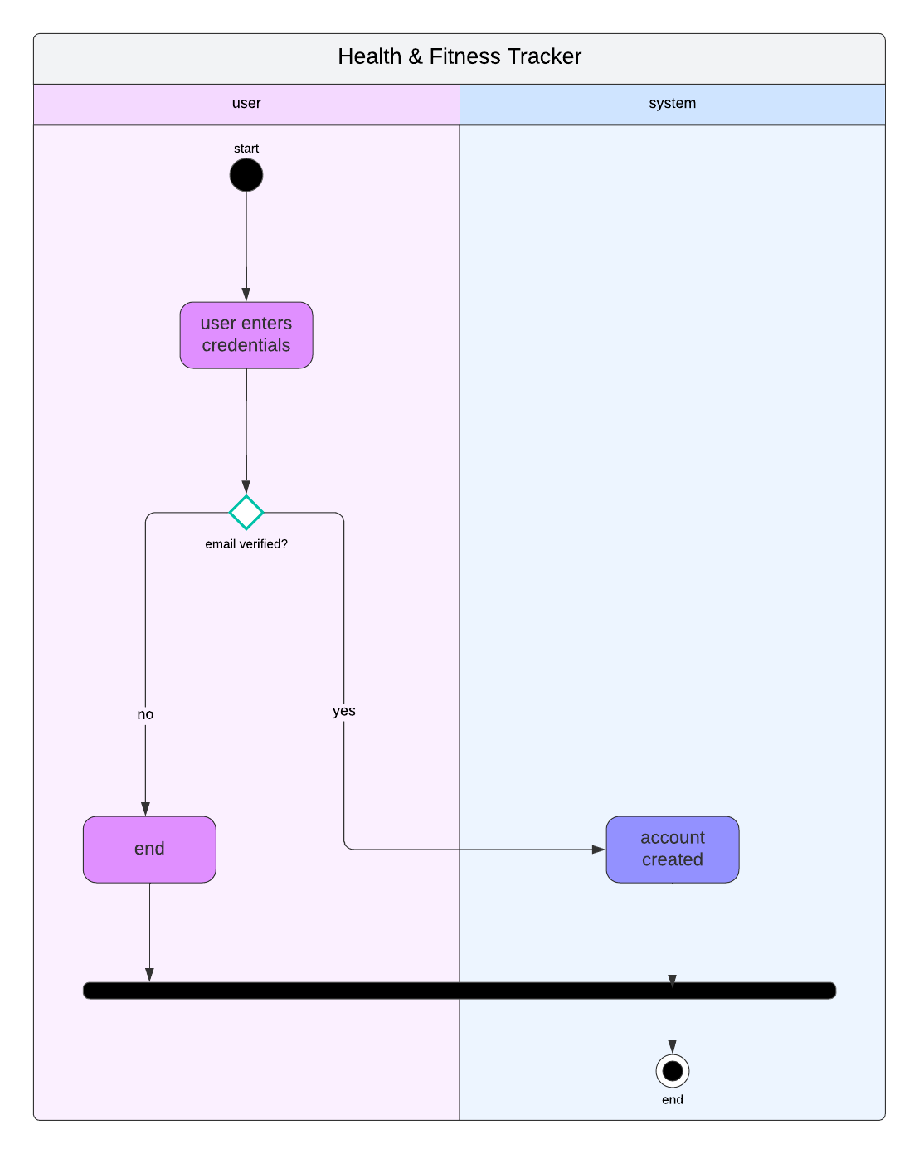

6.1.2 Meal Logging Process
1. Purpose: To show the process of logging a meal by the user and the interaction with the database.
2. Steps:
- User selects meal type: The user chooses meal type (breakfast, lunch, dinner) from the UI (Frontend Team).
- User enters meal details: The user inputs the meal name, portion size, and calories (Frontend Team).
- Backend processes data: The backend checks the meal data, calculates calories, and stores it in the database (Backend Team).
- Meal database lookup: If necessary, the backend looks up the meal details in the food database (Backend Team).
- Nutritional suggestions: The system may suggest healthier options based on user’s goal (AI/Nutritionist Team).
- Meal data stored: The meal is saved to the user's profile, and the user can view it in the meal log (Backend Team).
3. Departments/Teams Involved:
- Frontend Team: Meal input form and UI.
- Backend Team: Meal data storage, database access, and processing.
- Nutritionist/SMEs Team: Nutritional information and meal suggestions.
- QA Team: Testing meal logging functionality.
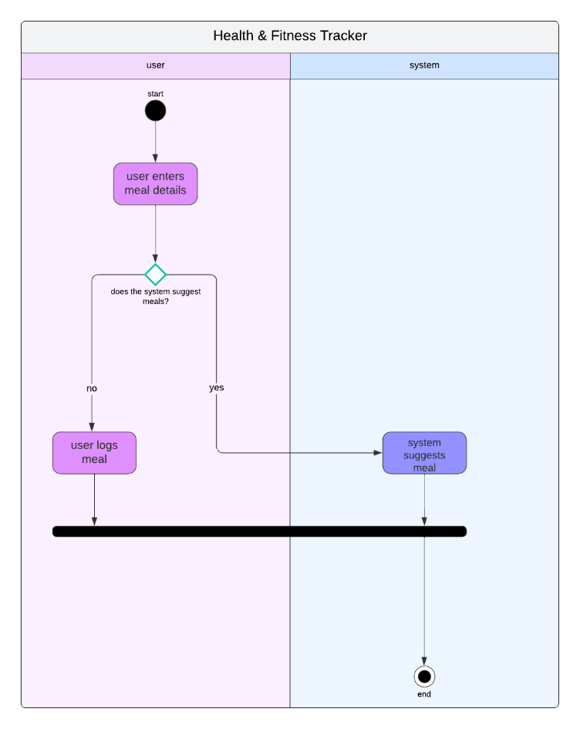

6.1.3 Activity Tracking Process
1. Purpose: To track the user's physical activity (workout or exercise).
2. Steps:
- User starts activity**: The user chooses the activity type (e.g., running, walking, cycling) and starts the workout (Frontend Team).
- Track activity duration**: The system tracks the start and end time of the activity (Frontend Team).
- Activity data sent to the backend**: Data such as calories burned, distance covered, and heart rate are sent to the backend (Backend Team).
- Wearable sync**: If applicable, the data is synced with a wearable device (Device Integration Team).
- Track progress towards goal**: The backend checks if the activity contributes to fitness goals (Backend Team).
- Save workout data**: The data is saved to the user's activity log (Backend Team).
- Activity summary displayed**: The system displays activity summary, such as calories burned, steps taken, etc. (Frontend Team).
3. Departments/Teams Involved:
- Frontend Team**: Activity interface, real-time data display.
- Backend Team**: Activity data processing and tracking.
- Device Integration Team**: Integration with wearable devices.
- QA Team: Testing of activity tracking functionality.
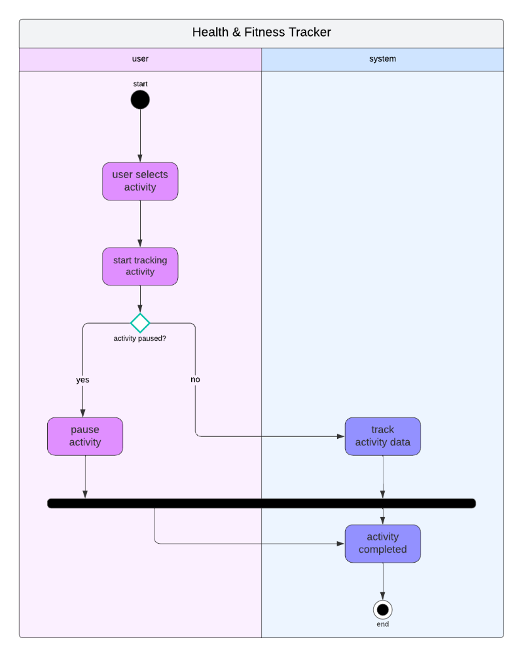

6.1.4 Goal Setting and Progress Tracking
1. Purpose: To set and track progress toward user-defined fitness goals.
2. Steps:
- User defines fitness goals: The user inputs goals such as weight loss, step count, calories burned, etc. (Frontend Team).
- Backend stores goals: The goals are stored in the user's profile (Backend Team).
- Track progress: As the user logs activities and meals, the system tracks progress against goals (Backend Team).
- Display progress: The system shows graphs and reports of the user's progress (Frontend Team).
- Suggest adjustments: Based on progress, the system may suggest adjusting goals or activity levels (AI/Analytics Team).
- Goal achieved: Once the goal is achieved, the system notifies the user (Backend Team).
3. Departments/Teams Involved:
- Frontend Team: Goal input interface, progress display.
- Backend Team: Goal tracking and data management.
- AI/Analytics Team: Progress analysis and suggestions.
- QA Team: Testing goal tracking and notifications.
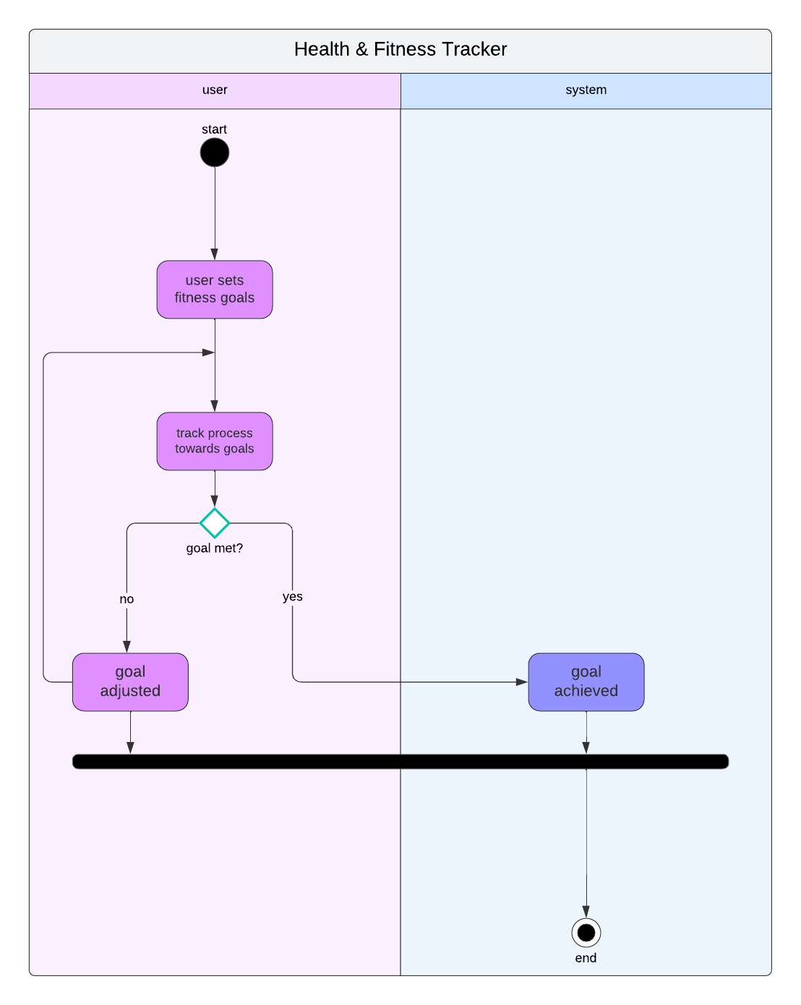

6.2 UseCase Diagram

6.2.1. Actors:
1. User:
Represents the individual using the system. The user can perform actions like logging in, updating their profile, editing meals, tracking activities, and viewing health metrics.
2. System:
Represents the backend or server-side system responsible for supporting the user’s actions, such as calculating health metrics, generating reports, and syncing data.

6.2.2. Cases:
1. Login:
Description: The user logs into the system to access their personal health and fitness data.
Extension: The system may include additional functionality, such as forgotten password handling or two-factor authentication.

2. Update Profile:
Description: The user updates personal details, such as height, weight, fitness goals, or contact information.
Dependencies: This use case depends on successful login and may impact health metrics calculations.

3. Edit Meal:
Description: The user can log or modify their meal details, including calories and macronutrients (protein, carbs, fat).
Inclusion: This use case includes a connection to reminders to prompt the user to update their meal logs.

4. Track Activity:
Description: The user logs physical activities such as walking, running, or gym sessions. The duration and type of activity impact health metrics like calories burned.
Inclusion: Includes the use case for reminders to notify users to log activities.

5. View Health Metrics:
Description: The user can view their current health statistics, such as weight, BMI, heart rate, and calories burned.
Dependencies: This depends on tracking activities, editing meals, and calculating metrics.

6. Generate Summary Report:
Description: The user generates a report summarizing their activities, meals, and health metrics over a specific period.
Inclusion: Includes calculating health metrics and syncing with the system to ensure data is up to date.

7. Reminders:
Description: The system generates automated notifications reminding the user to log meals, track activities, or check metrics.

8. Calculate Health Metrics:
Description: The system calculates health-related data, such as BMI and caloric balance, based on user inputs (e.g., meals and activities).

9. Sync:
Description: Synchronizes data between the user’s device and the backend system, ensuring up-to-date information across platforms.

6.2.3. Base Use Case: Login
Actor(s): User
Description: Enables the user to securely access their account to view and manage fitness-related data.

Preconditions:
The user must already be registered in the system.
The system must have valid user credentials stored.

Main Flow:
1. The user enters their credentials (email and password).
2. The system verifies the credentials.
3. Upon successful authentication, the user gains access to their dashboard.

Alternate Flow:
If the credentials are incorrect, the system prompts the user to retry or recover their account.

Postconditions:
The user is logged into the system, and session tracking begins.

6.2.4. Use Case: Edit Meal
Actor(s): User
Description: Allows the user to add, update, or remove meal entries to track daily calorie and macronutrient intake.

Preconditions:
The user must be logged in.

Main Flow:
1. The user selects a meal type (e.g., breakfast, lunch).
2. The user logs or updates meal details (e.g., name, calories, macronutrient breakdown)
3. The system stores the meal information and recalculates health metrics.

Alternate Flow:
If the meal data is incomplete or invalid, the system prompts the user to correct it.

Postconditions:
Updated meal data is saved, and reminders may be adjusted.

6.2.5. Use Case: View Health Metrics
Actor(s): User
Description: Displays an overview of the user's health metrics, including current weight, BMI, heart rate, and caloric balance.

Preconditions:
The user must have logged at least one activity or meal.

Main Flow:
1. The user navigates to the metrics page.
2. The system retrieves and displays health data based on logged inputs and calculations.
Postconditions:
The user has an updated view of their metrics.

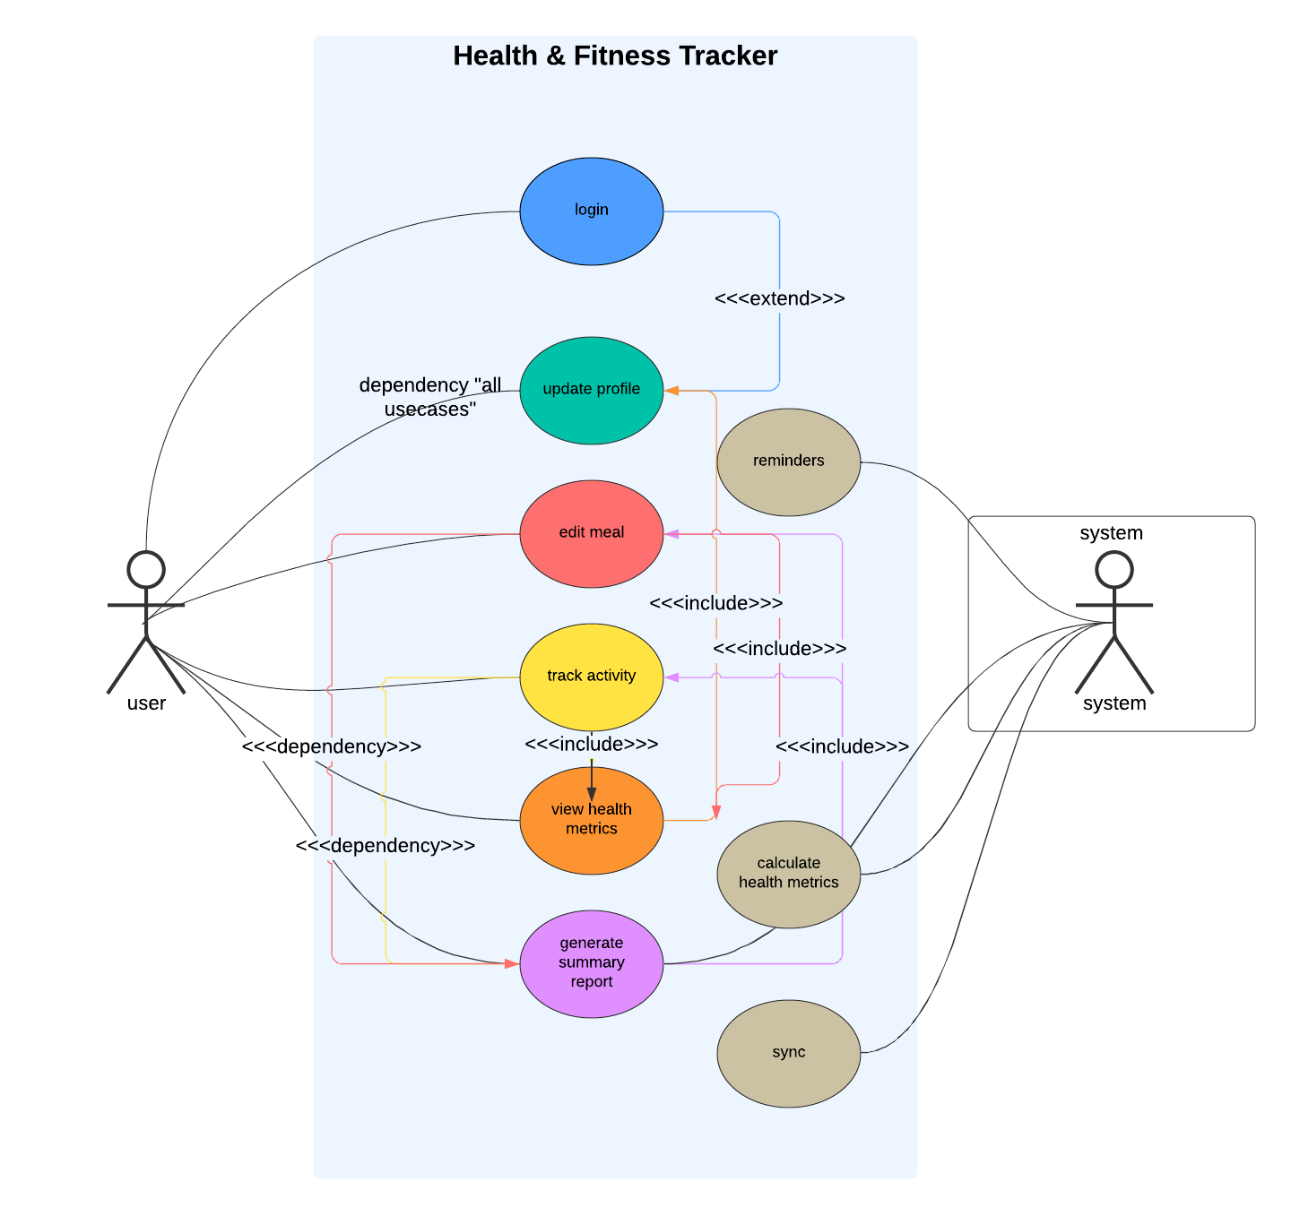.

6.3 Sequence Diagram
A sequence diagram shows how objects interact in a specific scenario and the order in which these interactions occur. Here are examples for the Health and Fitness Tracker system:

6.3.1 User Registration
- Actors: User, System (Frontend, Backend, Database)
- User enters their registration details (e.g., username, email, password).
- Frontend sends the data to the Backend for validation.
- Backend validates the data and checks if the email or username already exists in the Database.
- If the data is valid:
  - Backend stores the user details in the Database.
  - Backend sends a success response back to the Frontend.
  - Frontend shows a confirmation message to the User.
- If the data is invalid (duplicate user):
  - Backend sends an error message to the Frontend.
  - Frontend prompts the User to change their details.
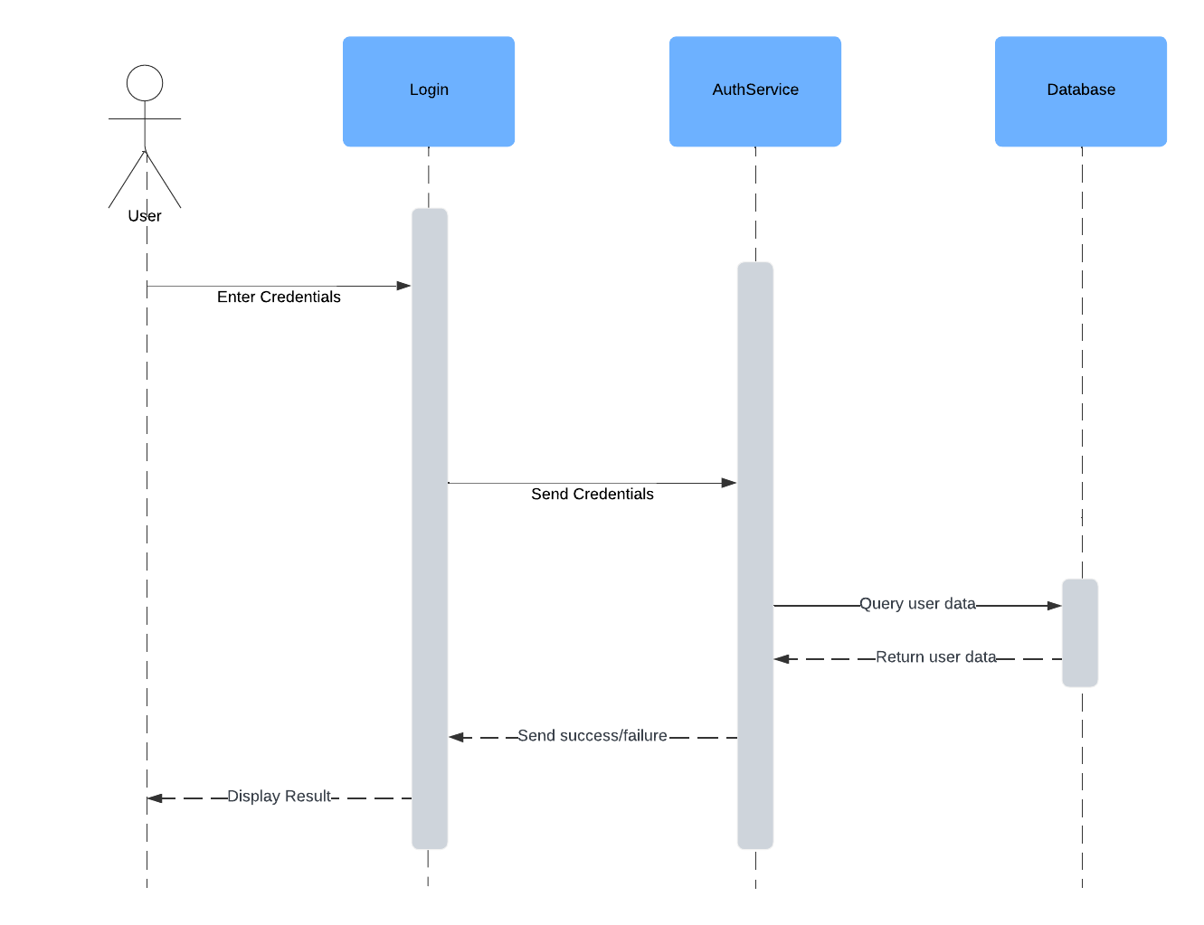

6.3.2 Meal Logging
- Actors: User, System (Frontend, Backend, Database)
- User selects "Log Meal" in the UI.
- Frontend prompts the user to enter meal details (e.g., type, calories, nutrients).
- User submits the meal details to Frontend.
- Frontend sends the data to Backend.
- Backend processes the data and stores it in the Database.
- Backend sends a success response to the Frontend.
- Frontend shows a confirmation message to the User.
- Optionally, Backend updates Metrics (e.g., calories consumed).
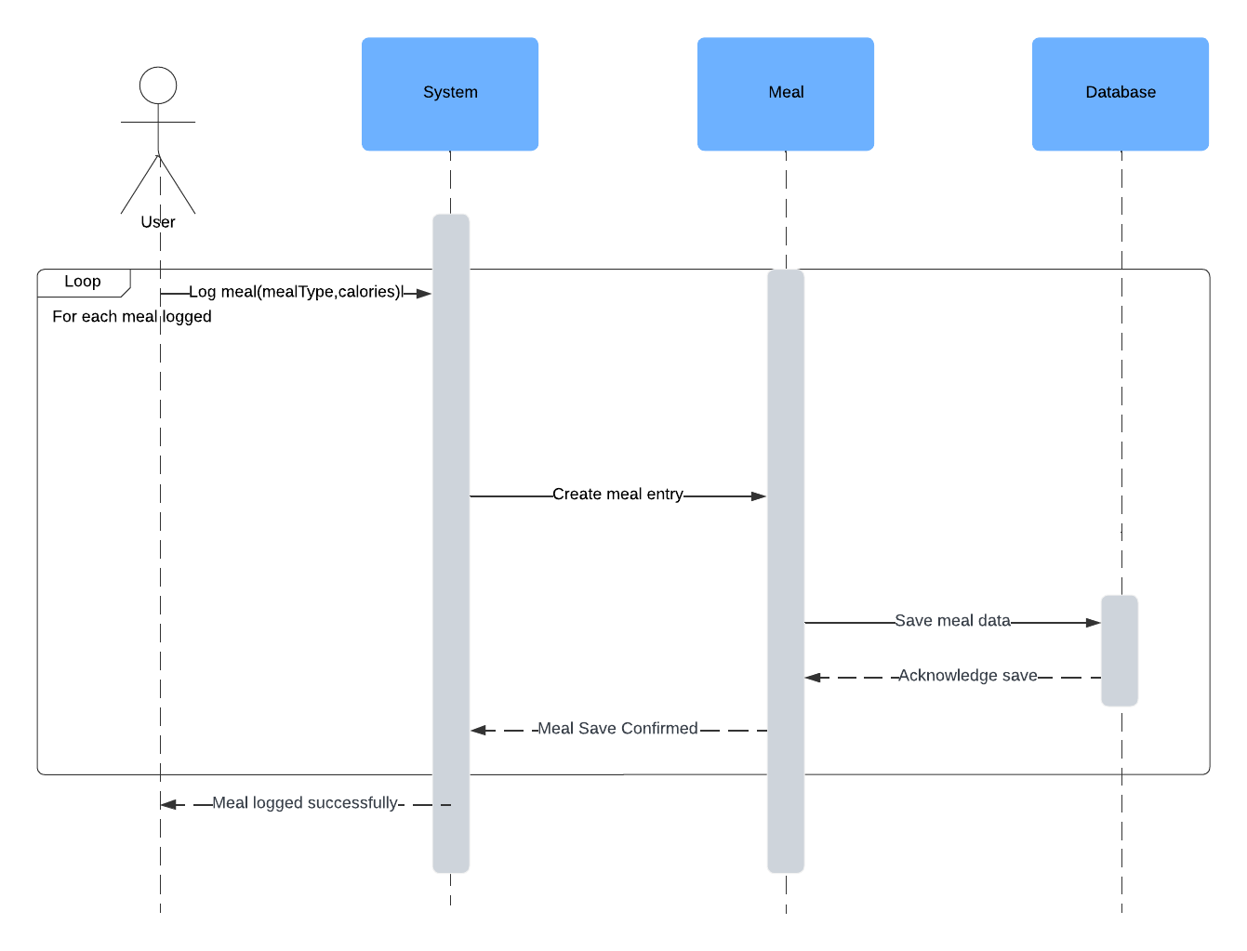

6.3.3 Activity Tracking
- Actors: User, System (Frontend, Backend, Database)
- User selects an activity (e.g., running) in the app.
- Frontend prompts the user for activity details (e.g., duration).
- User starts the activity by clicking "Start Tracking."
- Frontend sends the activity data (type, duration) to the Backend.
- Backend stores the activity details in the Database and begins tracking.
- As the activity progresses, the Frontend periodically fetches updates from the Backend (e.g., calories burned, duration).
- When the activity is completed, the User clicks "Stop Tracking."
- Backend finalizes the activity data (calories burned) and stores the final metrics.
- Frontend displays the final activity summary to the User.
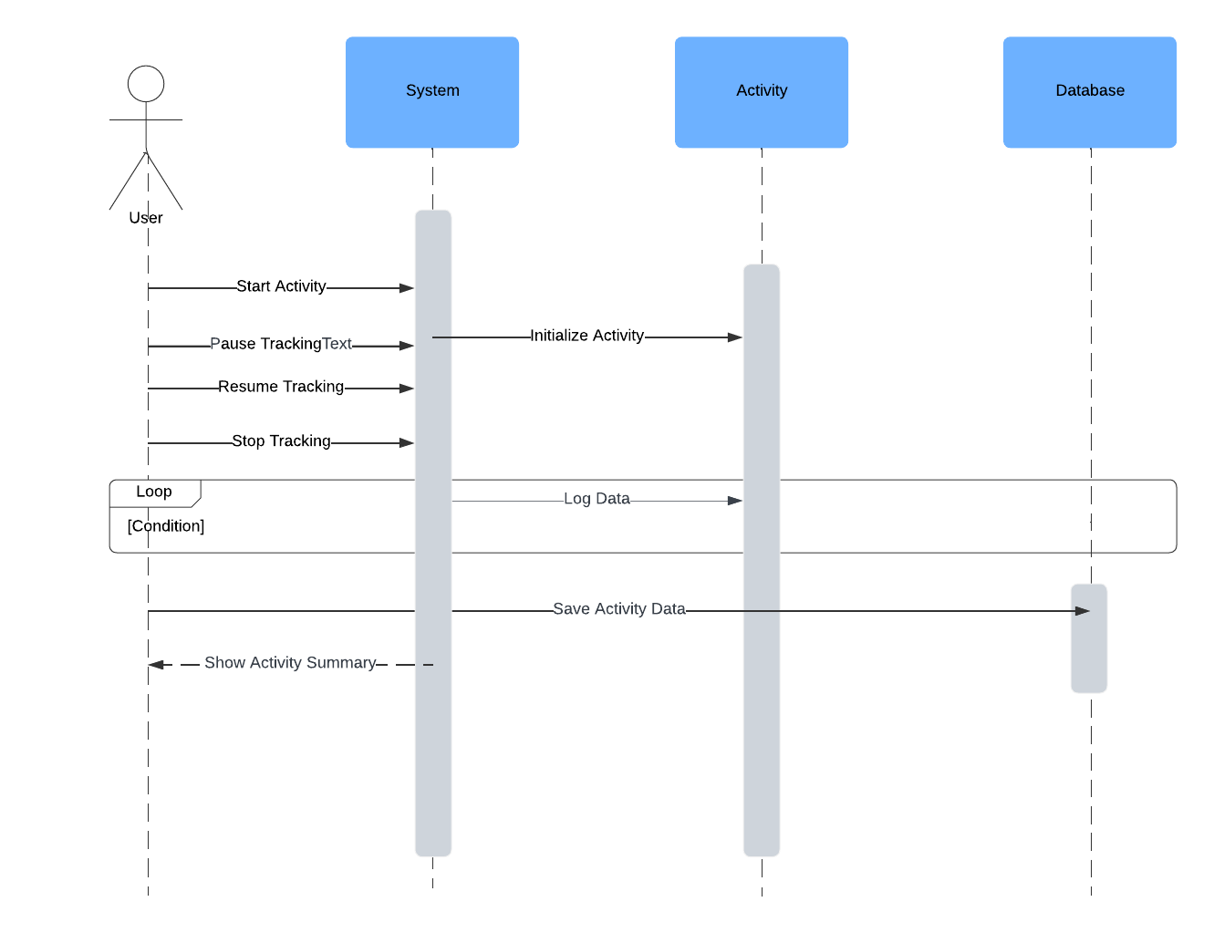

6.4 Class Diagram

6.4.1. Key classes include:
- User: Handles registration and profile management.
- Profile: Handles user profile info.
- Meal: Manages meal logging.
- Activity: Tracks physical activities.
- Metrics: Stores health data like weight and sleep.
- Report: Handles the generated data.

6.4.2. Classes Overview
- User
  - Attributes:
    - userID: Unique identifier for the user.
    - username: The username used by the user to log in.
    - email: The user's email address.
    - password: The user's encrypted password.
    - createdAt: Timestamp indicating when the user was created.
  - Methods:
    - login(username, password): Authenticates the user using their username and password.
    - updateProfile(profile): Updates the user’s profile information.
    - viewMetrics(): Retrieves the user’s metrics.
    - logout(): Logs the user out of the system.
  - Relationships:
    - Each user has exactly one profile.
    - Users can track multiple meals, activities, and generate reports.

- Profile
  - Attributes:
    - profileID: Unique identifier for the profile.
    - age: User's age.
    - weight: User's weight.
    - height: User's height.
    - goals: Fitness goals defined by the user.
    - updateAt: Timestamp of the last profile update.
  - Methods:
    - updateProfile(age, weight, height, goals): Updates the user's physical profile.
    - calculateBMI(): Calculates the user's Body Mass Index (BMI).
    - getProfileInfo(): Retrieves profile details.
  - Relationships:
    - A profile is directly tied to a user and cannot exist independently.

- Metrics
  - Attributes:
    - metricsID: Unique identifier for the metrics.
    - steps: Number of steps taken.
    - caloriesBurned: Total calories burned.
    - heartRate: User's heart rate.
    - distance: Distance covered.
  - Methods:
    - updateMetrics(steps, caloriesBurned, heartRate, distance): Updates the user's health metrics.
    - calculateProgress(): Computes progress toward fitness goals.
    - viewMetrics(): Retrieves the user's current metrics.
  - Relationships:
    - Metrics are closely tied to the user and are updated as the user logs activities.

- Meal
  - Attributes:
    - mealID: Unique identifier for the meal.
    - mealType: Type of meal (e.g., breakfast, lunch, dinner).
    - calories: Total calories in the meal.
    - nutrients: Nutritional details (e.g., protein, carbs, fats).
  - Methods:
    - logMeal(mealType, float, nutrients): Logs a meal with its details.
    - calculateCalories(): Computes the total caloric value of the meal.
    - getMealDetails(): Retrieves meal details for display.
  - Relationships:
    - A user can log multiple meals, but meals exist independently.

- Activity
  - Attributes:
    - activityID: Unique identifier for the activity.
    - type: Type of activity (e.g., running, cycling).
    - duration: Duration of the activity in hours.
    - caloriesBurned: Total calories burned during the activity.
    - startTime: Activity start time.
    - endTime: Activity end time.
  - Methods:
    - startTracking(type): Starts tracking a new activity.
    - stopTracking(): Stops tracking the current activity.
    - getCaloriesBurned(): Computes calories burned during the activity.
    - getActivityDetails(): Retrieves details of the activity.
  - Relationships:
    - Activities are logged independently of the user and reports but are linked back to the user.

- Report
  - Attributes:
    - reportID: Unique identifier for the report.
    - startDate: Start date of the reporting period.
    - endDate: End date of the reporting period.
    - reportType: Type of report (e.g., summary, detailed).
    - createdAt: Timestamp of report creation.
  - Methods:
    - generateReport(startDate, endDate): Creates a report for a specific date range.
    - viewReport(): Displays the report details.
    - exportReport(format): Exports the report in a specific format (e.g., PDF, Excel).
  - Relationships:
    - Reports aggregate user data (meals, activities, and metrics) and exist independently once generated.

6.4.3. Key Relationships
- User → Profile:
  - A one-to-one relationship. Each user has a unique profile that holds their physical details and fitness goals.
- User → Metrics:
  - A one-to-one relationship. A user’s metrics (e.g., steps, calories burned) are tied directly to them.
- User → Meal:
  - A one-to-many relationship. Users can log multiple meals over time.
- User → Activity:
  - A one-to-many relationship. Users can track multiple activities to monitor their fitness routines.
- User → Report:
  - A one-to-many relationship. Users can generate multiple reports based on their data.

6.4.4. Workflow
- User Interaction:
  - The user logs in, updates their profile, logs meals, and tracks activities.
  - The system records metrics (e.g., steps, calories burned) based on user inputs and activities.
- Data Aggregation:
  - Data from meals, activities, and metrics is aggregated to generate reports.
- Report Generation:
  - Reports can be created for specific timeframes to provide insights into user performance and goal progress.
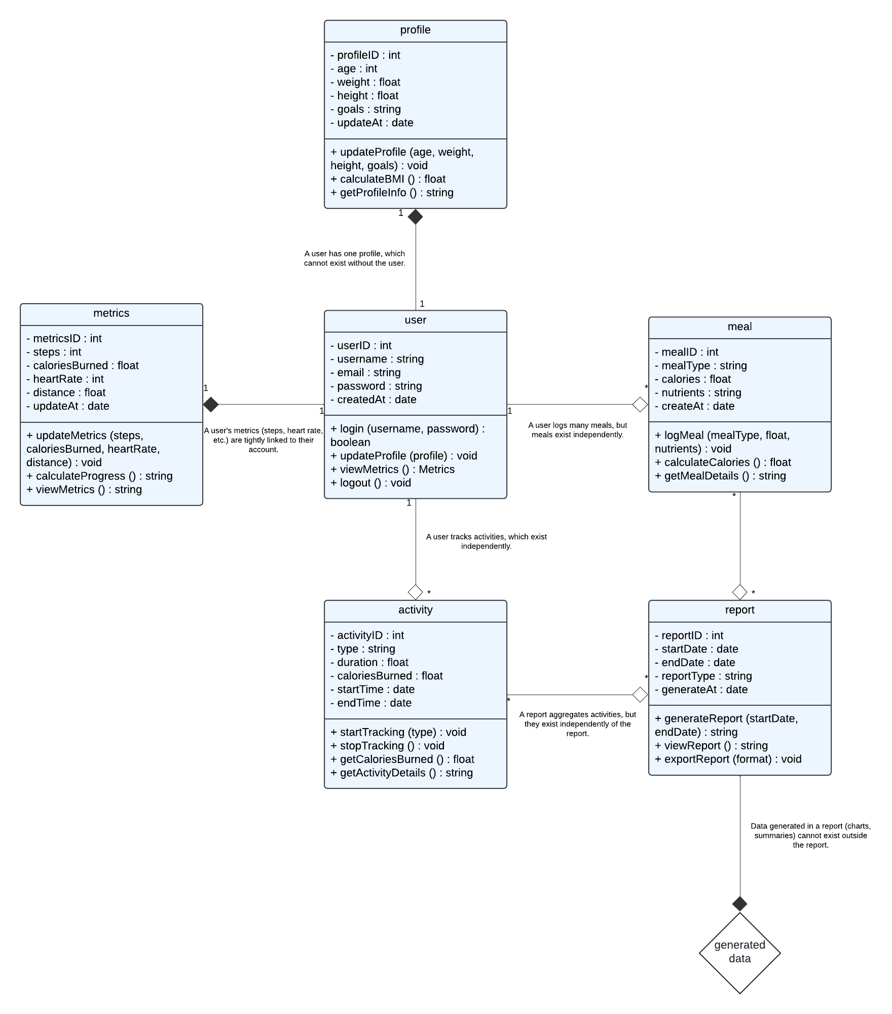

6.5 State Diagram
Model the different states of an object (or entity) throughout its lifecycle, based on inputs and events. For each state, actions may be triggered to transition the object to another state.

User Authentication State Diagram
1. Purpose: To model the states of the user authentication process.
2. States:
      - Initial State: User is not logged in (default state).
      - Logging In: User enters credentials.
      - Validating Credentials: Backend checks credentials.
      - Logged In: Credentials are valid, and user successfully logs in.
      - Login Failed: Invalid credentials, user is prompted to retry.
      - Password Reset: If the user forgot the password, the system sends a reset link.
      - Logged Out: User logs out and returns to the initial state.
3. Transitions:
      - Initial State → Logging In: User initiates the login process.
      - Logging In → Validating Credentials: User submits credentials for validation.
      - Validating Credentials → Logged In: Credentials are verified as valid.
      - Validating Credentials → Login Failed: Credentials are invalid, prompting a retry.
      - Login Failed → Logging In: User retries login with new credentials.
      - Login Failed → Password Reset: User opts to reset the password.
      - Password Reset → Logging In: User resets the password and attempts to log in again.
      - Logged In → Logged Out: User logs out of the system.
4. Departments/Teams Involved:
- Frontend Team: User interface for login and password reset.
- Backend Team: Authentication logic, password reset.
- Security Team: Ensuring safe login and handling of credentials.
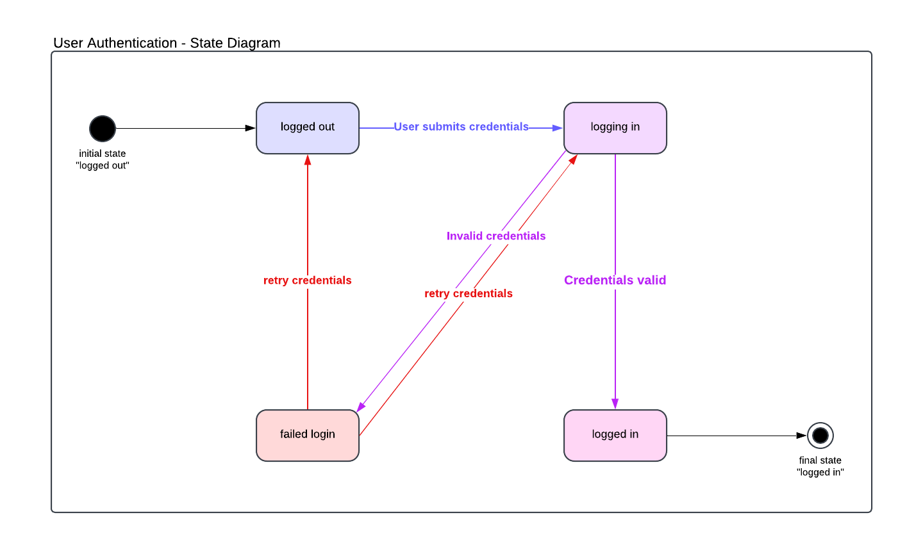

Meal Lifecycle State Diagram
1. Purpose: To describe the states a meal goes through, from creation to deletion.
2. States:
- Initial State: Meal Created.
- Meal Logged: Meal is logged into the system.
- Meal Updated: User edits meal details.
- Meal Deleted: Meal is removed from the system.
- Final State: End of meal lifecycle.
3. Transitions:
- Meal Created → Meal Logged: A new meal is logged.
- Meal Logged → Meal Updated: Meal details are edited.
- Meal Updated → Meal Deleted: Meal is deleted after being updated.
- Meal Logged → Meal Deleted: Meal is deleted without updates.
4. Departments/Teams Involved:
- User Interface Team: Provides interface for meal logging and editing.
- Backend Team: Handles meal data processing.
- Data Analytics Team: Monitors meal data for insights.
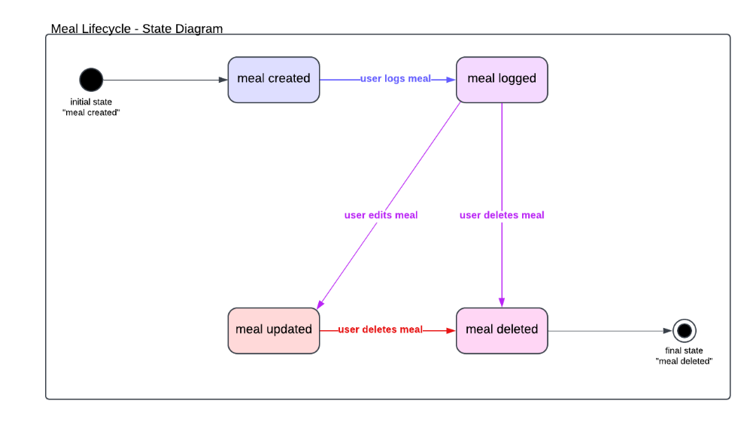

Activity Lifecycle State Diagram
1. Purpose: To capture the various states of an activity as it progresses from start to completion.
2. States:
- Initial State: Not Started.
- Tracking Activity: Activity is actively being tracked.
- Paused Activity: Activity is temporarily paused.
- Activity Completed: Activity is finished.
- Final State: End of activity lifecycle.
3. Transitions:
- Not Started → Tracking Activity: Activity begins.
- Tracking Activity → Paused Activity: Activity is paused.
- Paused Activity → Tracking Activity: Activity resumes.
- Tracking Activity → Activity Completed: Activity is completed.
4. Departments/Teams Involved:
- Product Team: Designs the activity tracking feature.
- Engineering Team: Implements activity tracking and state transitions.
- Customer Success Team: Assists users with activity tracking issues.
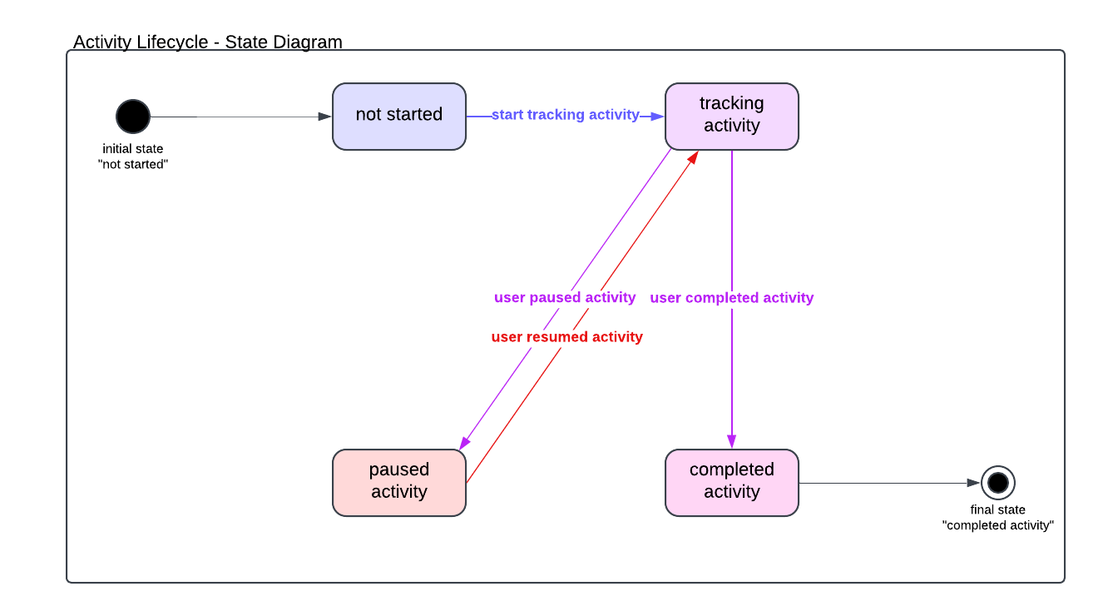

6.6 Context Diagram
high-level diagram that represents the system as a single entity and shows its interactions with external entities (users, external systems, etc.). It focuses on the inputs and outputs to/from the system without going into internal details.

For Health and Fitness Tracker system, the Context Diagram could show how the system interacts with external entities like the User, Wearable Devices, and Nutrition API.

6.6.1 Detailed View
1. System: Represented as a central entity (rectangle) labeled "Health and Fitness
Tracker".
2. External Entities:
- User: Interacts with the system to log activities, view progress, etc.
- Wearable Device: Syncs data like steps, heart rate, etc., with the system.
- Nutrition API: Provides nutritional data for meals.
- Database: Stores health data and user information.
3. Data Flows:
- User → System: Logs activity, logs meals, views reports.
- System ↔ Wearable Devices: Syncs health data like steps, calories.
- System ↔ Nutrition API: Fetches nutritional info for meals.
- System ↔ Database: Stores user data and activity history.

Key Elements
- System: The central system being developed.
- External Entities: Users or systems outside the boundaries of the main system.
- Data Flows: Represent the exchange of data between the system and external entities.
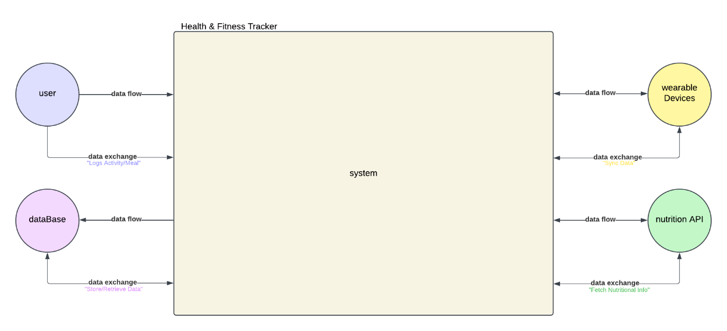

6.7 Architecture Diagram
Architecture design refers to the conceptual structure and logical organization of a system. It defines how the various components of a system interact with each other to fulfill its requirements. In software development, architecture design serves as a blueprint for both the system and the project, ensuring that all parts work together cohesively while adhering to predefined requirements.

The system architecture includes the frontend, backend, database, and optional external APIs.
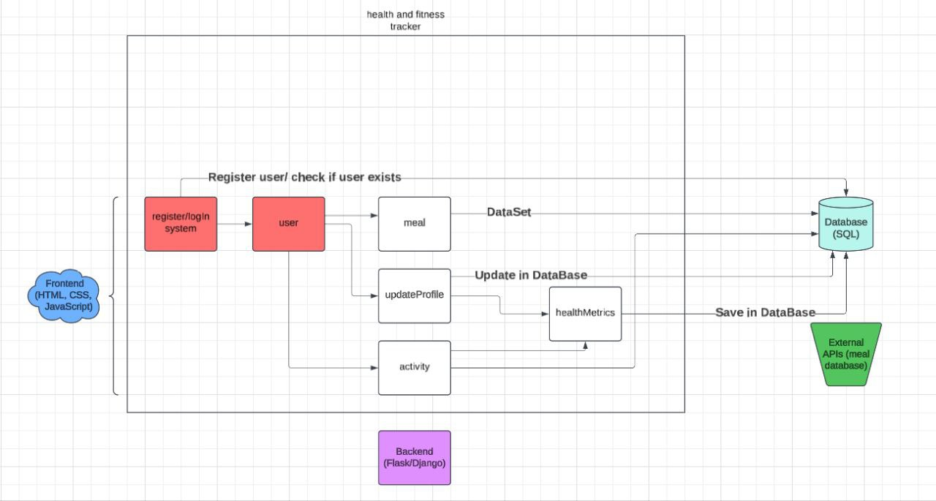

6.8 Wireframes
Wireframes are designed for:
- Sign-Up and Sign-In pages.
- User profile, displaying the rest of the user information
- Home page, displaying all the user data
- Check-In page, displaying weekly progress
- Goals page, displaying user long term goals
- Reminders page, displaying system sent reminders or user added reminders
- Settings page, displaying all the user account and privacy settings
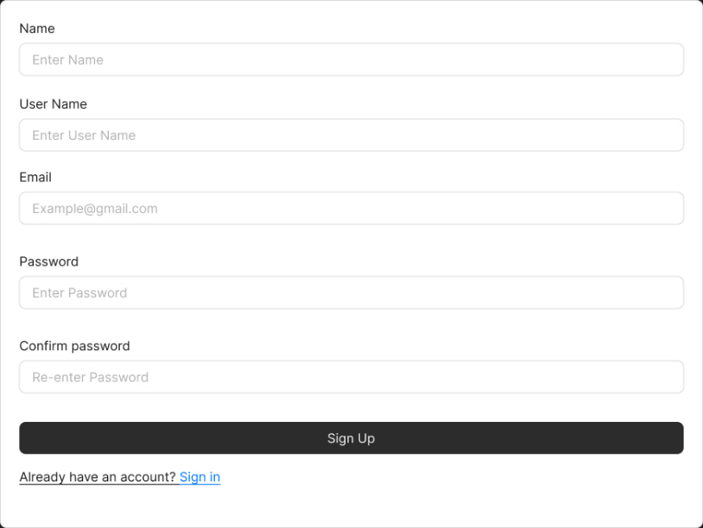
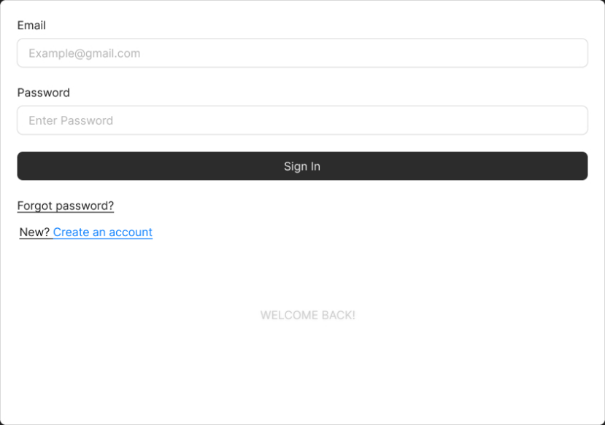
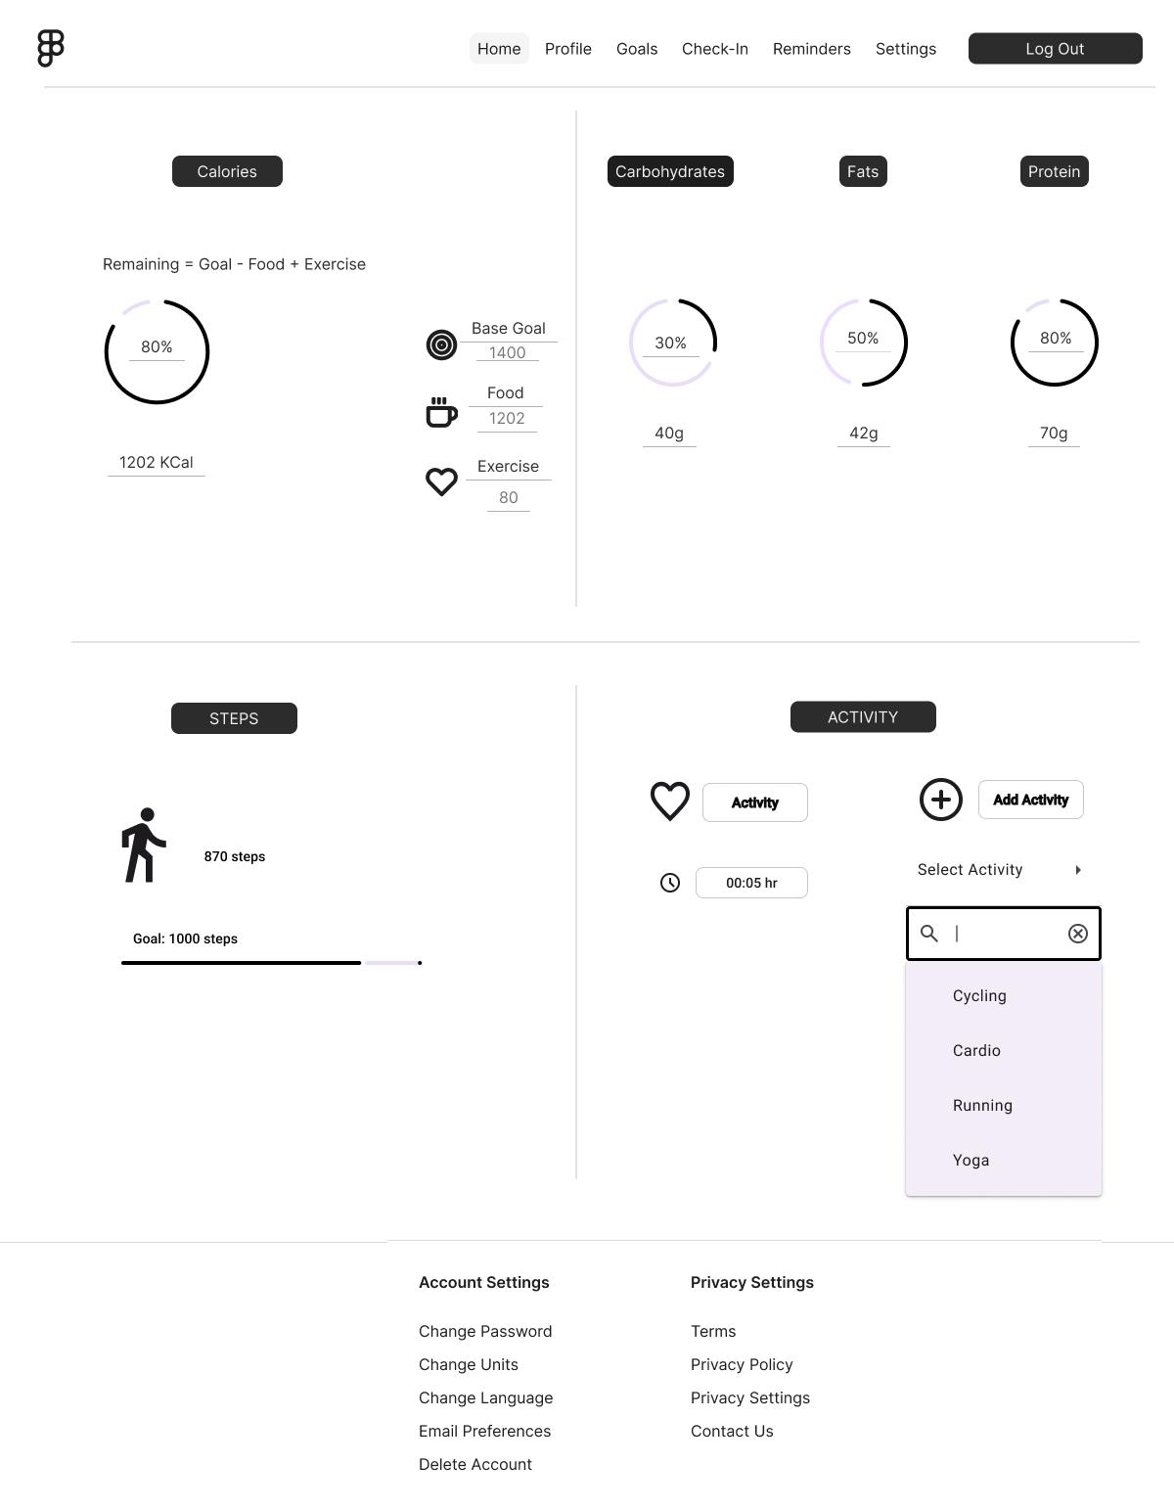

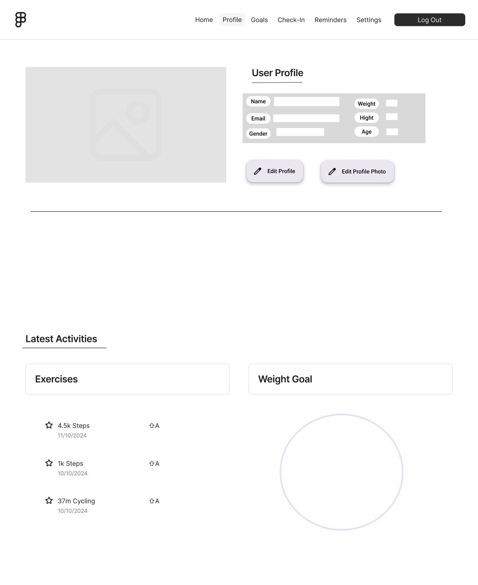
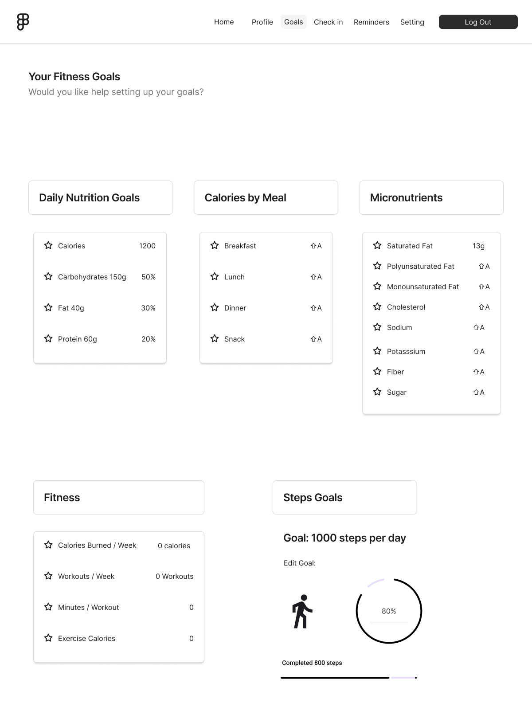
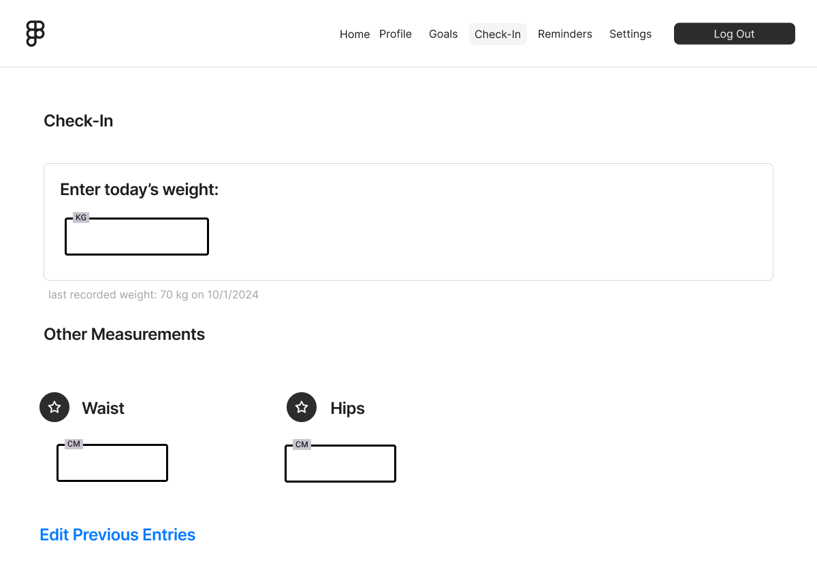
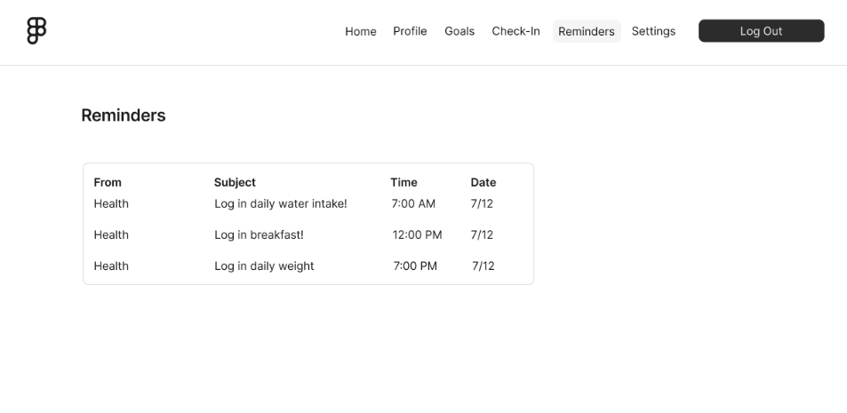
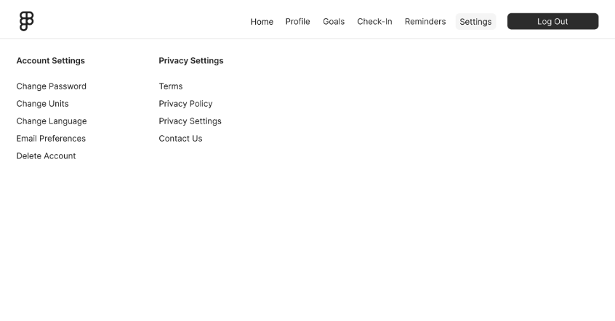

7. Implementation Plan

7.1 Minimum Viable Product (MVP) “prototype”
The MVP will include:
- User authentication.
- Basic meal logging.
- Activity tracking.

7.2 Agile Practices and Methodology
- User stories and sprint plans created in GitHub Projects.
- Bi-weekly sprint reviews with burndown charts.

8. Testing and Validation

8.1 Test Cases
Sample test cases:
- Verify user registration functionality.
- Ensure meal logging data is stored correctly.
- Validate activity tracking calculations.
Test Case Name | Description | Test Steps | Expected Result | Status
User Registration Test | - Validates that a user can register successfully. | 1. Navigate to registration page.  2. Enter valid user details (username, email, password).  3. Click Register. | - User is successfully registered and redirected to the login screen. | Pass
Meal Logging Test | Ensures that meal data is logged correctly. | 1. Login as a user.  2. Navigate to "Log Meal".  3. Enter meal details (e.g., meal type, calories).  4. Submit. | - Meal is logged and stored in the database, and user receives a success message. | Pass
Activity Tracking Test | Verifies activity tracking functionality. | 1. Login as a user.  2. Navigate to "Track Activity".  3. Select activity type.  4. Start and stop activity. | - Activity details (duration, calories burned) are accurately tracked and saved. | Pass
User Login Test | Validates user login functionality. | 1. Navigate to login page.  2. Enter valid credentials (username, password).  3. Click login. | - User is authenticated and logged into the system. | Pass
Report Generation Test | Verifies report generation and export. | 1. Login as a user.  2. Select a date range for the report.  3. Generate the report.  4. Export the report to PDF. | - Report is generated with the correct data and exported to the chosen format (e.g., PDF). | Pass
Password Reset Test | Tests the password reset functionality. | 1. Click "Forgot Password" on the login page.  2. Enter email address.  3. Follow the password reset link. | - User receives a reset link and can successfully set a new password. | Pass
Profile Update Test | Verifies that the user profile can be updated. | 1. Login as a user.  2. Navigate to the profile page.  3. Update profile details (age, weight).  4. Save changes. | - User profile is updated successfully and changes are reflected on the profile page. | Pass

8.2 User Testing Plan
Feedback will be gathered through surveys from early adopters.

9. Risk Analysis

Risk Description | Likelihood | Impact | Severity | Mitigation Strategy
User Data Breach: Unauthorized access to user data. | High | High | Critical | Implement strong encryption, two-factor authentication, regular security audits, and secure data storage.
System Downtime: Unavailability of the application. | Medium | High | High | Set up redundancy, monitor system uptime, use cloud hosting with SLAs, and create disaster recovery plans.
Data Loss: Accidental loss of user data. | Medium | High | High | Regular data backups, version control, and implement database transaction management.
Incorrect Data Entry: User entering incorrect meal/activity data. | Medium | Medium | Medium | Implement form validation, provide clear instructions, and include confirmation steps.
Third-Party API Failure: Nutrition API or wearable device sync failure. | Low | High | Medium | Have fallback APIs, monitor API status, and ensure proper error handling for missing data.
Scalability Issues: System performance problems as user base grows. | Medium | High | High | Optimize code, use load balancing, and scale infrastructure as needed.
User Retention: Low user engagement and high churn rates. | High | Medium | High | Implement gamification, reminders, and personalized notifications to encourage regular use.
Integration Issues: Challenges integrating with wearable devices or other systems. | Medium | Medium | Medium | Thorough testing, collaboration with device vendors, and ensuring compatibility with different devices.
Regulatory Compliance: Failure to comply with health data regulations. | Medium | High | High | Stay informed on regulations, implement compliance checks, and integrate data protection features.
App Compatibility: Issues with app performance on different devices or OS versions. | Medium | Medium | Medium | Test on multiple devices and platforms, include support for older versions of OS, and optimize app performance.
Feature Creep: Adding unnecessary features leading to project delays. | Medium | Medium | Medium | Prioritize features for MVP, follow Agile methodology, and keep stakeholder expectations clear.
User Experience Issues: Poor app usability leading to negative reviews. | Medium | Medium | Medium | Conduct user testing, focus on intuitive design, and iterate based on feedback.
Lack of Documentation: Inadequate system documentation for future updates. | Low | Medium | Medium | Regularly update technical documentation, use version control, and maintain detailed API documentation.

10. Deployment

10.1 Hosting and Environment Setup
The app will be hosted on any cloud host with SQL as the database.

10.2 CI/CD Pipeline
GitHub Actions will automate testing and deployment.

11. Design Patterns
This project implements a secure login system with session management, CSRF (Cross-Site Request Forgery) protection, and the application of several design patterns to ensure scalability, maintainability, and clear separation of concerns. The primary features of the system include user authentication, secure session handling, and the prevention of CSRF attacks.

Design Patterns Used

11.1 MVC (Model-View-Controller)

11.1.1 Purpose:
The MVC design pattern was used to separate the logic of the application into three main components:
- Model: Responsible for handling data (e.g., user authentication, database interactions).
- View: Represents the UI and user-facing elements (e.g., login form, HTML output).
- Controller: Handles user input and interaction between the Model and the View (e.g., processing login credentials).

11.1.2 Implementation:
- Model: The UserModel.php file contains the logic for interacting with the database, including verifying user credentials.
- View: The login_view.php file contains the HTML code that renders the login form and any messages to the user.
- Controller: The LoginController.php file handles user input, processes the form submission, validates user credentials, and manages redirection after login.

11.2 Singleton Pattern

11.2.1 Purpose:
The Singleton pattern ensures that a class has only one instance and provides a global point of access to it. It is particularly useful for managing shared resources like the database connection or session handling.

11.2.2 Implementation:
In this project, the Singleton pattern was used for managing the database connection. This ensures that the connection is established once and reused throughout the application, which optimizes performance and resource management.

11.3 Factory Pattern

11.3.1 Purpose:
The Factory pattern is used to create objects without specifying the exact class of object that will be created. It allows for easy extension of the system without modifying existing code.

11.3.2 Implementation:
The Factory pattern was used for creating user objects based on user roles (e.g., admin, regular user). This allows for easy modification and extension if new user roles need to be added in the future.

11.4 Strategy Pattern

11.4.1 Purpose:
The Strategy pattern allows for the creation of interchangeable algorithms that can be selected at runtime. This is useful for handling different authentication methods or strategies (e.g., traditional username/password vs. social login).

11.4.2 Implementation:
In this project, the authentication logic is handled using the Strategy pattern. Different strategies for authentication (like username/password authentication and future support for social login) can be easily added by creating new strategy classes.

11.5 Dependency Injection (DI)

11.5.1 Purpose:
Dependency Injection allows for decoupling components by passing their dependencies (such as services or models) rather than having them create their own dependencies. This makes the application more modular and easier to test.

11.5.2 Implementation:
In this project, Dependency Injection is used to inject services (like the UserService or DatabaseService) into controllers. This decouples the logic of controllers from the logic of the services and models, making the code more flexible and easier to maintain.

How These Patterns Were Used in This Project
1. MVC
- We used MVC to separate the concerns of handling user requests (Controller), managing data (Model), and presenting the UI (View).
- This made the code easier to maintain and extend as new features were added (such as CSRF protection and future authentication strategies).
2. Singleton
- The Database connection was handled using the Singleton pattern to ensure only one instance of the database connection was used across the application, reducing overhead and improving resource management.
3. Factory
- The User creation logic used the Factory pattern to instantiate user objects based on user roles (admin, regular user). This allowed for easy role-based management and future extensibility of roles without changing the core logic.
4. Strategy
- The Authentication logic used the Strategy pattern to allow interchangeable authentication methods. Currently, the system supports username/password authentication, but new strategies (like Google OAuth or Facebook login) can be added by implementing a new strategy class.
5. Dependency Injection
- We applied Dependency Injection to decouple the controllers from services like UserService and DatabaseService. This made the system easier to maintain and test, as the controllers could focus on handling logic, while the services were injected.

By applying these design patterns (MVC, Singleton, Factory, Strategy, and Dependency Injection), we ensured that the project is scalable, maintainable, and easy to extend. Each pattern provides distinct benefits that contributed to the overall architecture and structure of the application, making it easier to handle new requirements and future changes.

12. Conclusion and Future Work
The Health and Fitness Tracker lays the foundation for a comprehensive health tracking tool. Future enhancements include:
- Integration with wearable devices (optional).
- Database generated meal and activity recommendations.

13. GitHub Project Link
https://github.com/alysakr-11/health-fitness-tracker-01-

